CREATE IBM WATSON IOT PLATFORM AND DEVICE

|  |  |
| --- | --- |
| TEAM ID | PNT2022TMID33663 |
| PROJECT NAME | IOT Based Smart Crop Protection System for Agriculture |

# IBM Watson IOT platform and device development STEPS:

1. The unique IBM id and password are used to create an IBM cloud account.

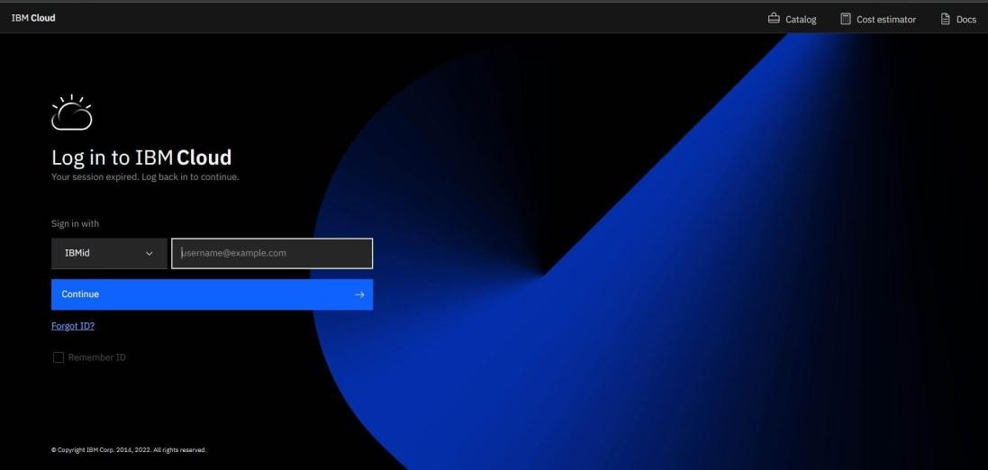

1. Web site for IBM Cloud
2. 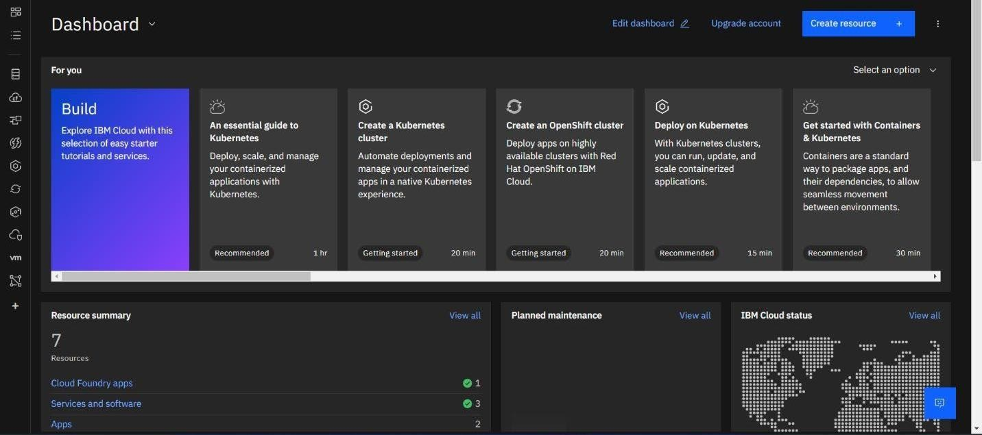Select the catalogue link at the top.

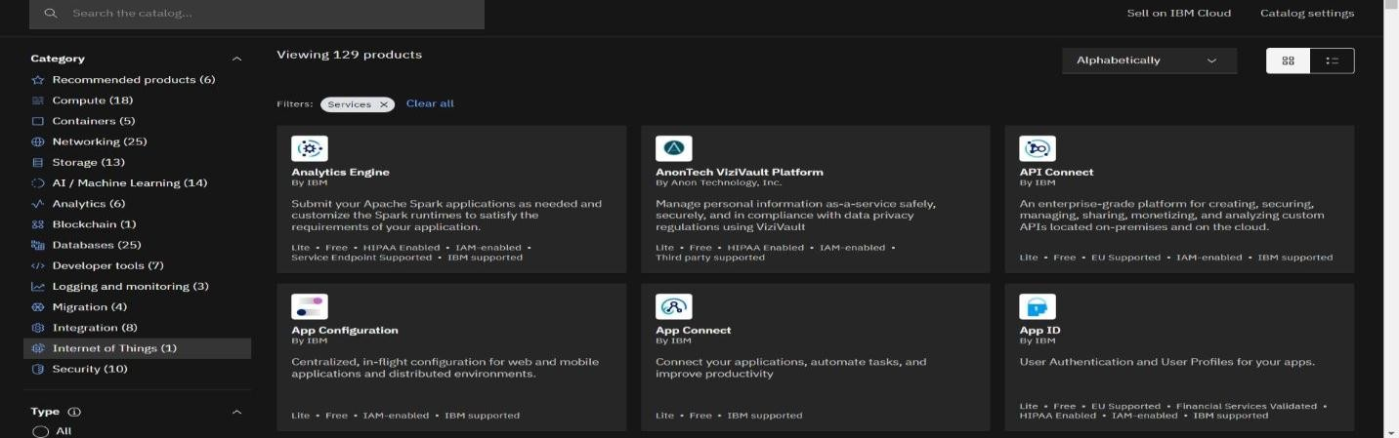

1. Select IoT from the list of categories.

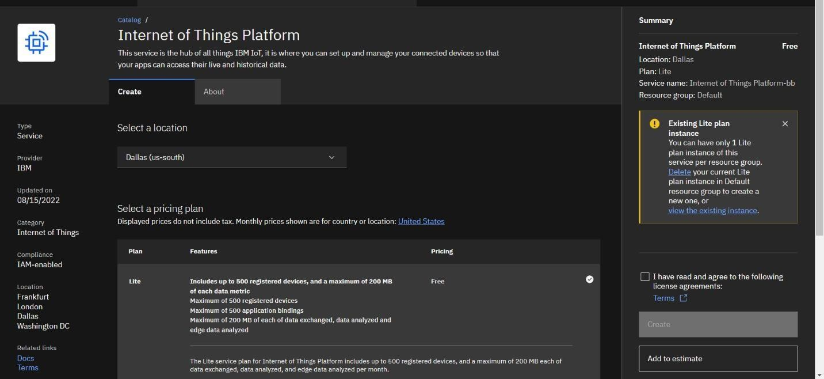

1. If a lite already exists, remove it; otherwise, you cannot create another.

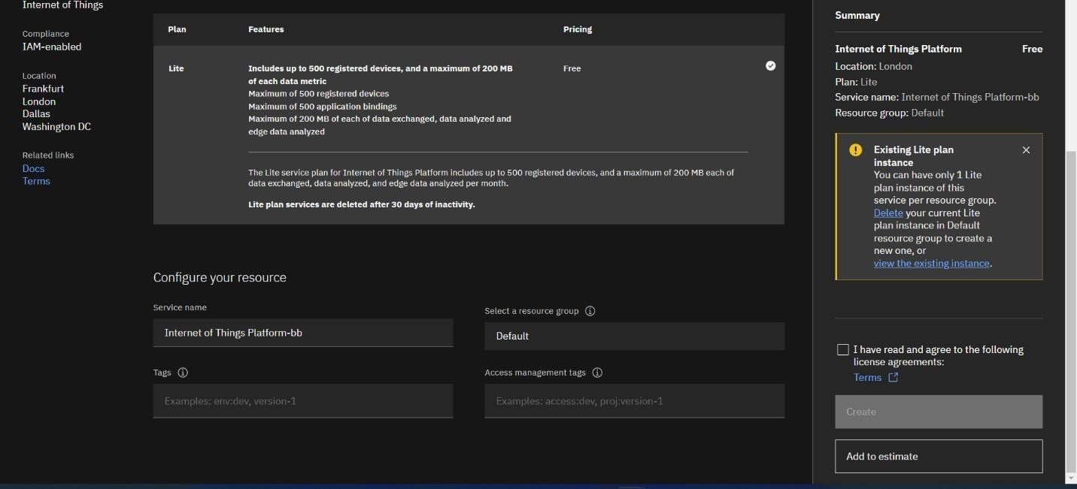

1. Type the service name into the box under "Configure Your Resource," select the plan, check the box next to "Agree with Agreements," and then click "Create."

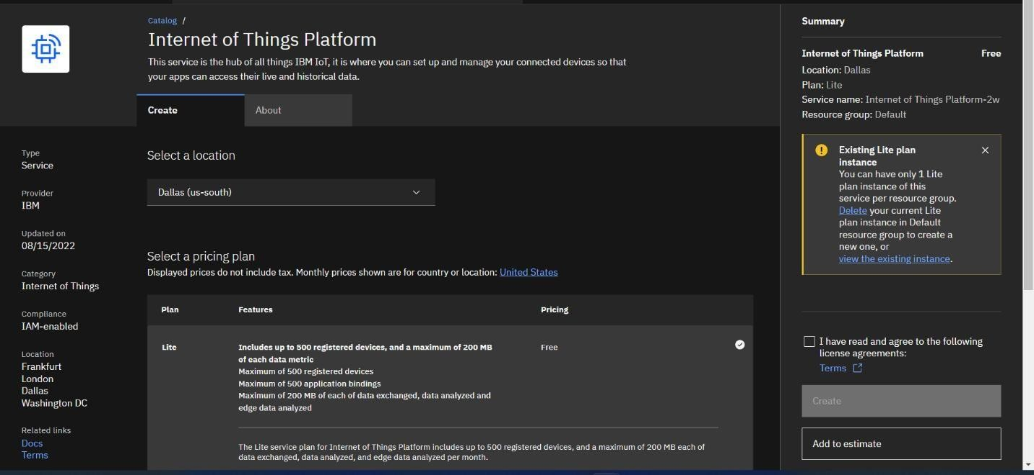

1. click create

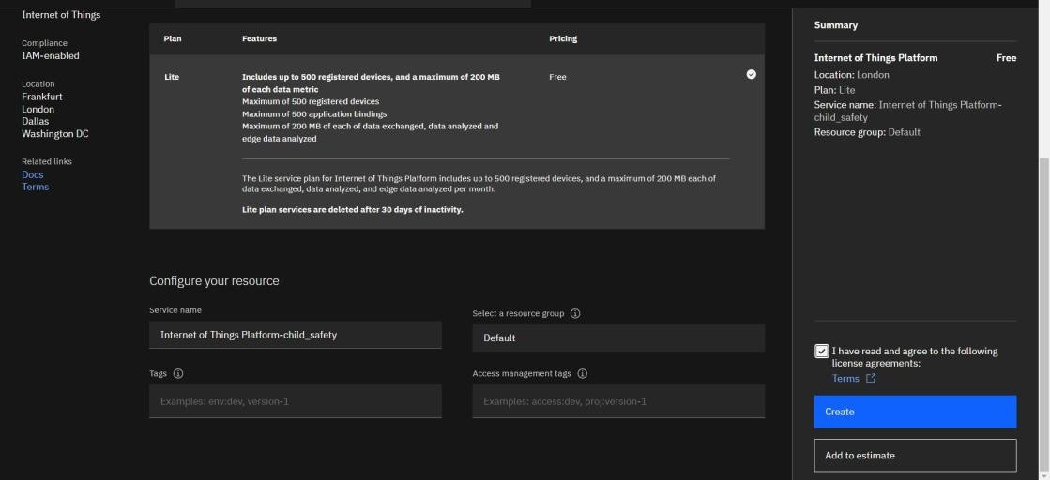

1. Platform for Internet of Things There will be a new page called Child Safety with options like Manage, Plan, and Connection.

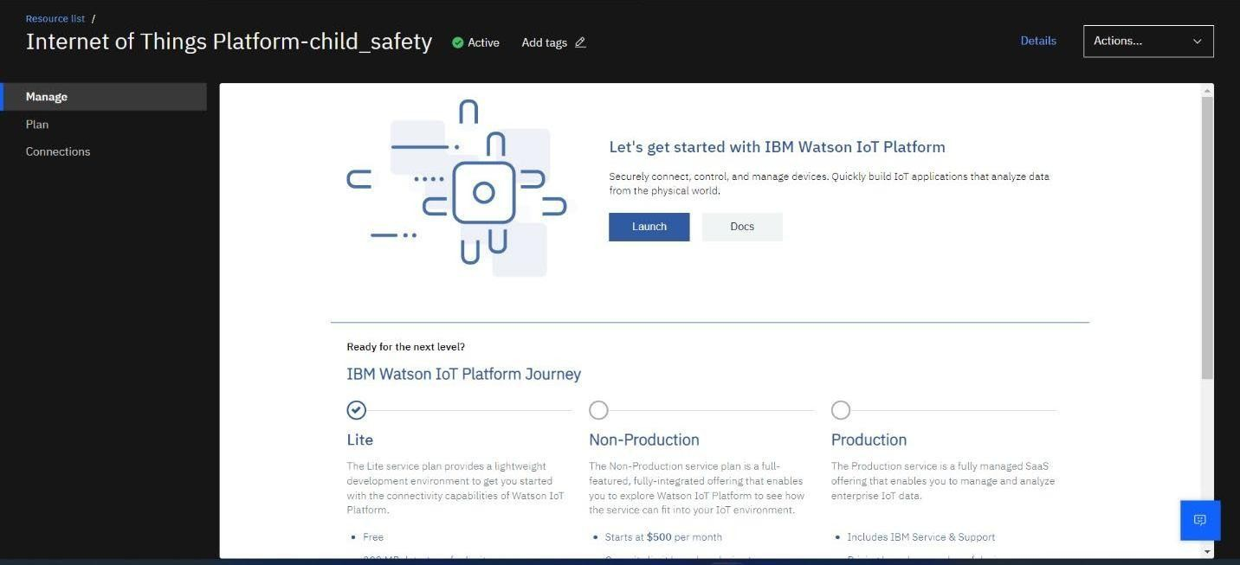

1. The connection is used to link IOT with other services, while manage is for launch and plan informs us about the payment package and its upgrades.

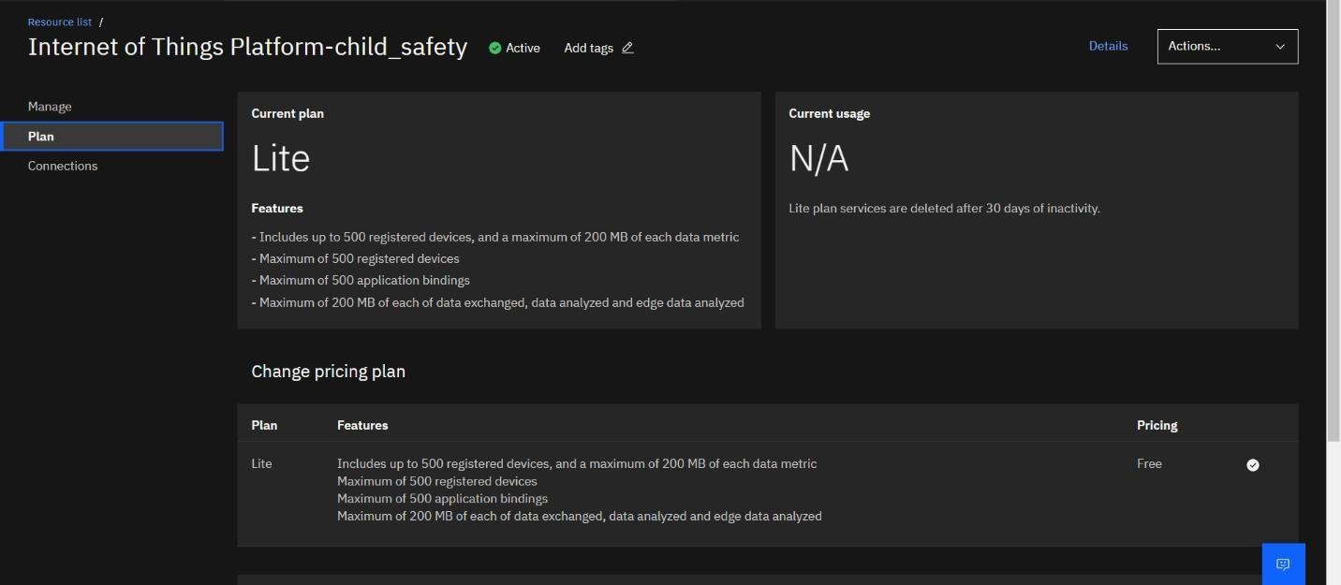

1. When you click the launch button on the Manage tab, this page will appear.

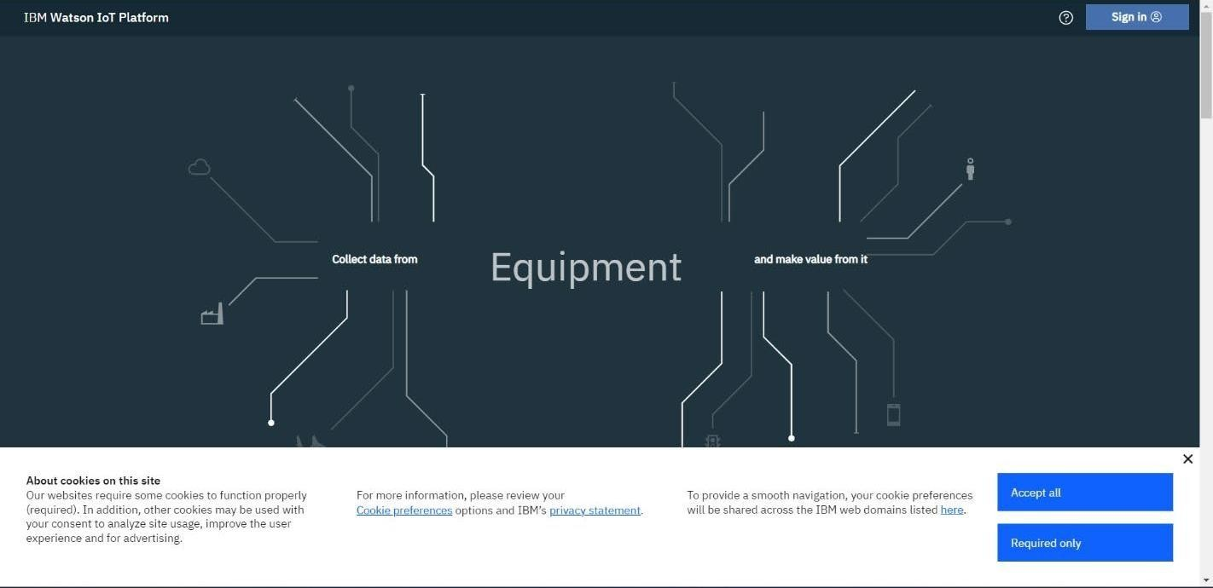

1. Fill in the information to create a device by logging into the Watson Cloud.

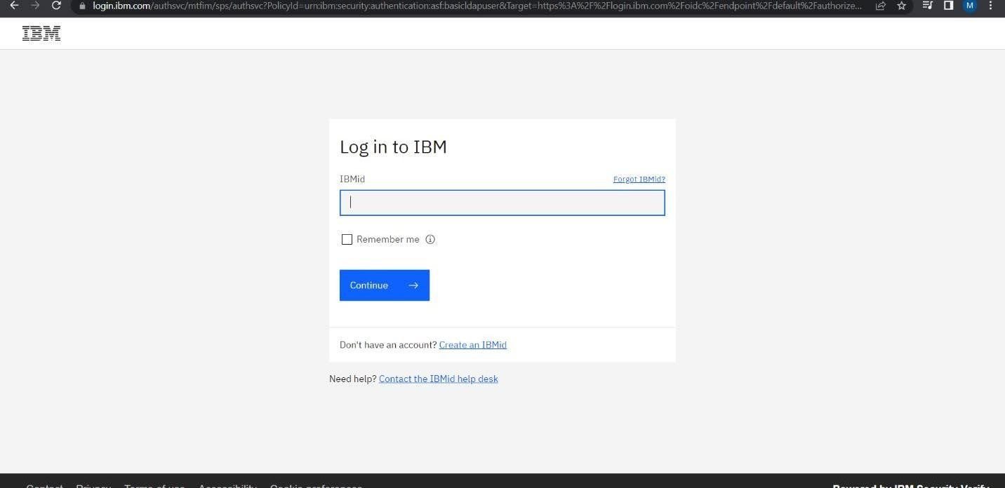

1. After logging in, the name is displayed and the page returns to the home page.

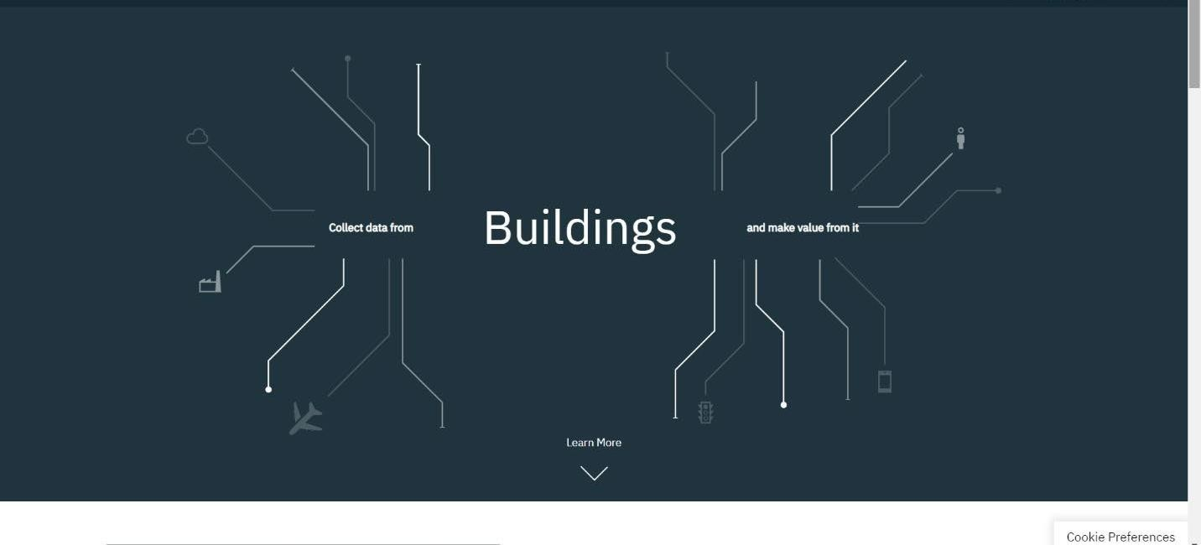

1. Clicking the launch button once more will open this tab, which contains a tool for creating and adding devices as well as for displaying information about them.

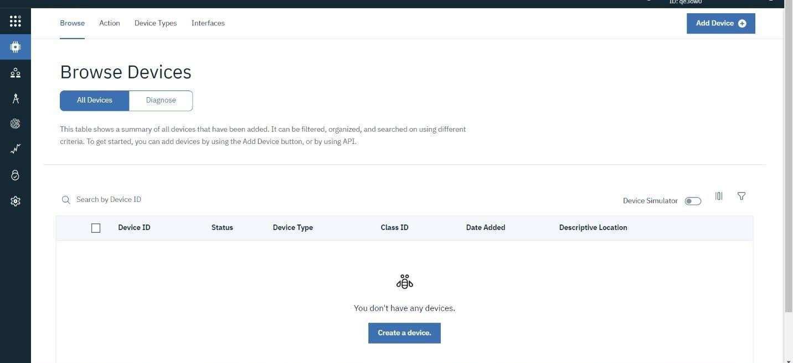

1. If necessary for the project, the general setting can be changed using the setting tab.

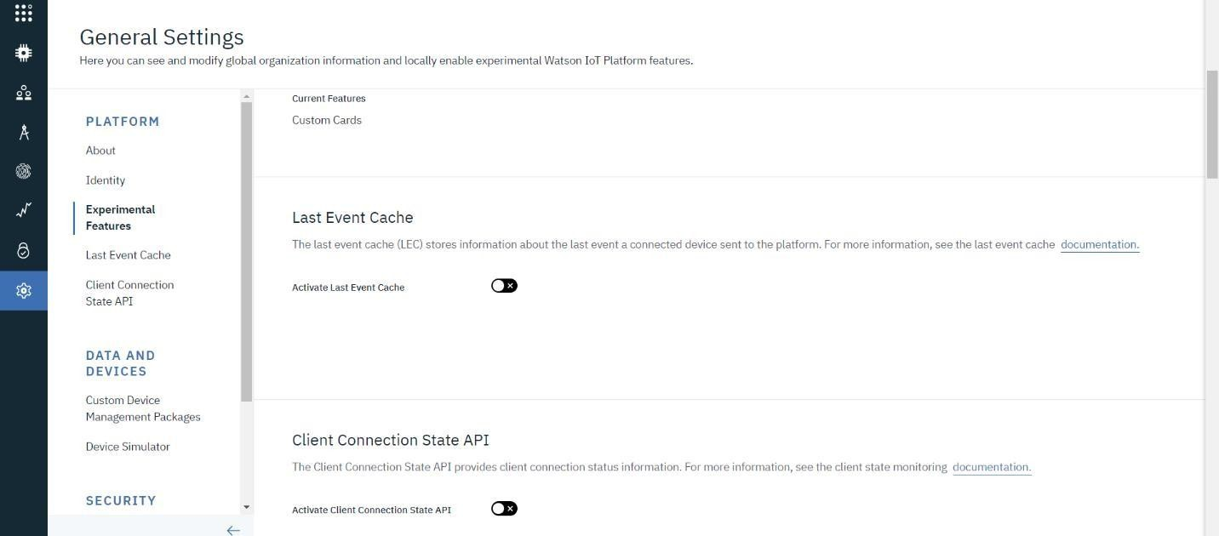

1. We can change the type of security connection and the specification in the security tab.

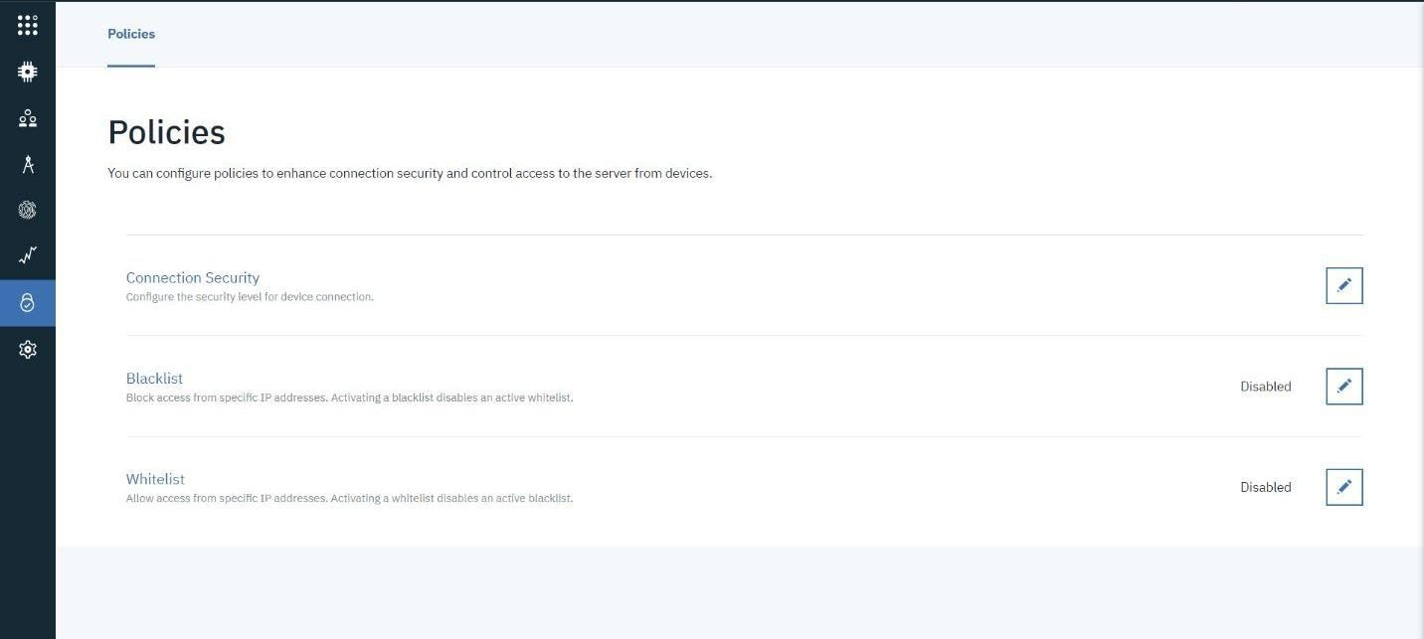

1. Usage summarises the amount of data transferred between the devices and the IBM cloud.

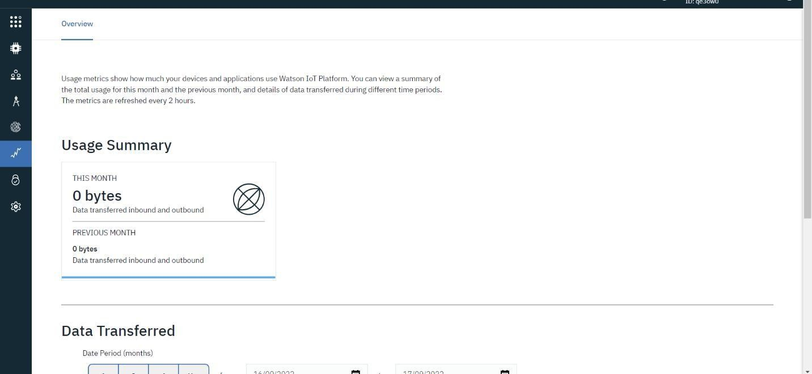

1. The team members are added to the platform through the member tab.

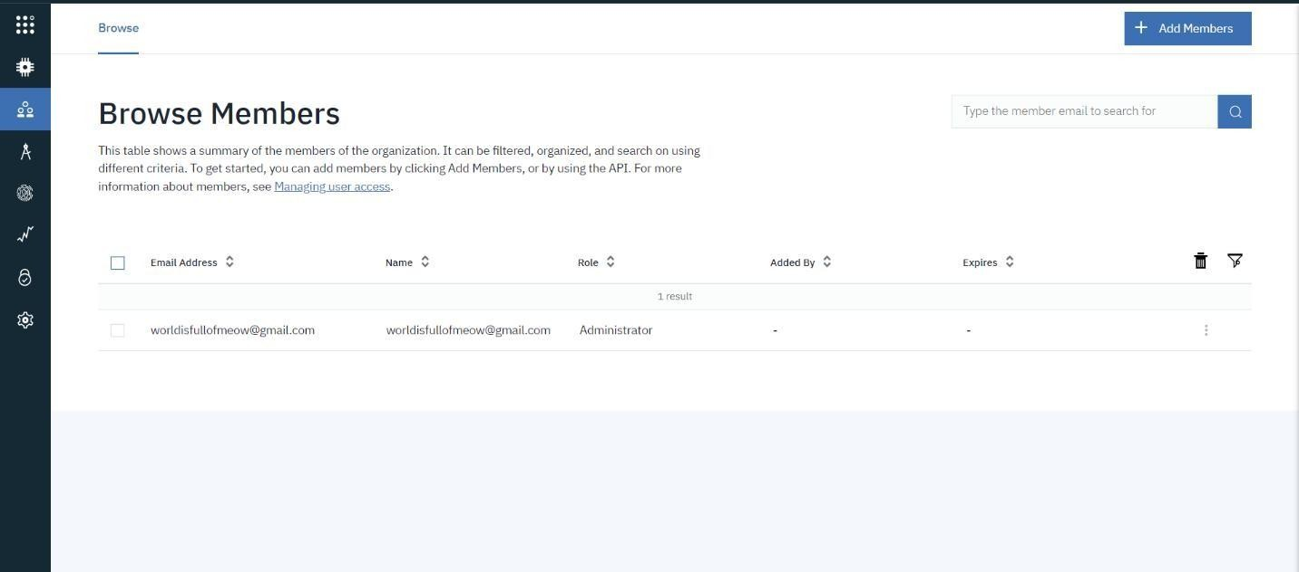

1. When you want to connect to another platform and integrate with other services, you use this tab.

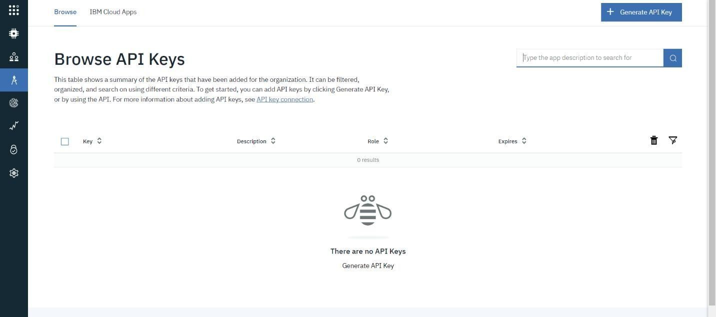

1. Select the device tab, select Add Device, enter the device type and device id, and select Next.

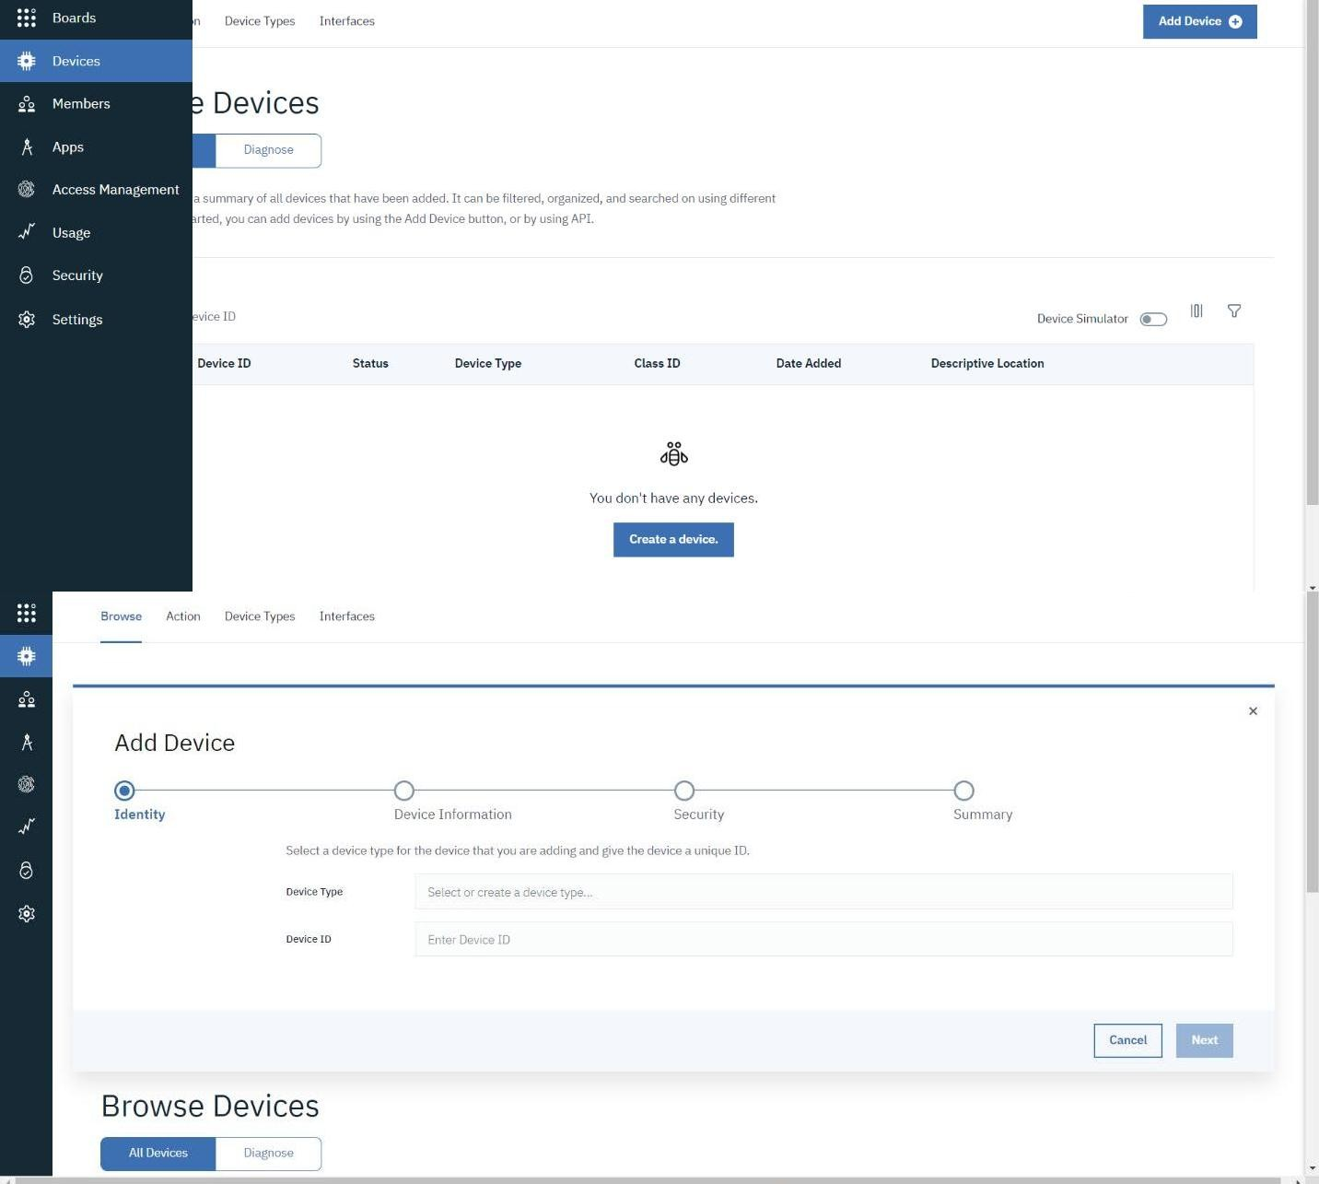

1. This page to add additional information and of the hardware

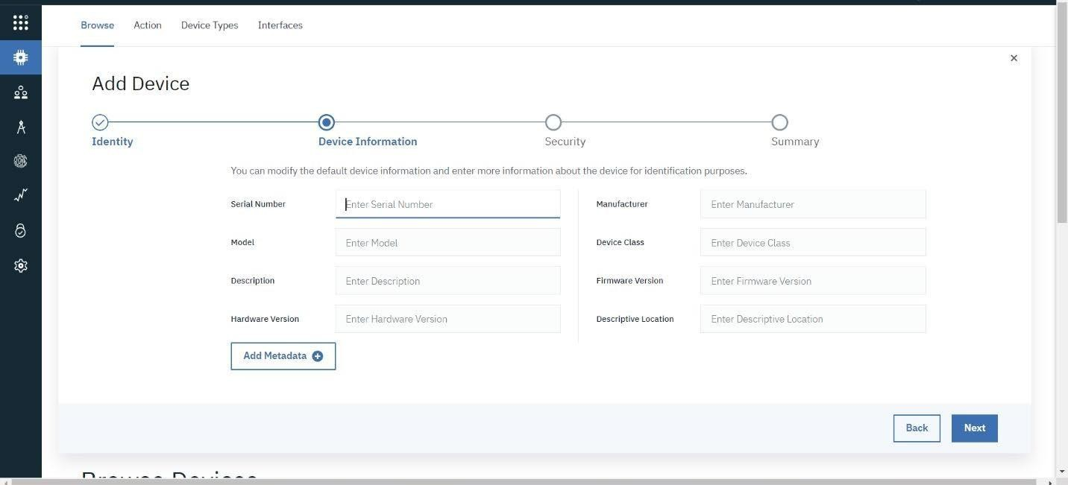

1. After clicking next, the security screen appears, where we perform authentication token id.

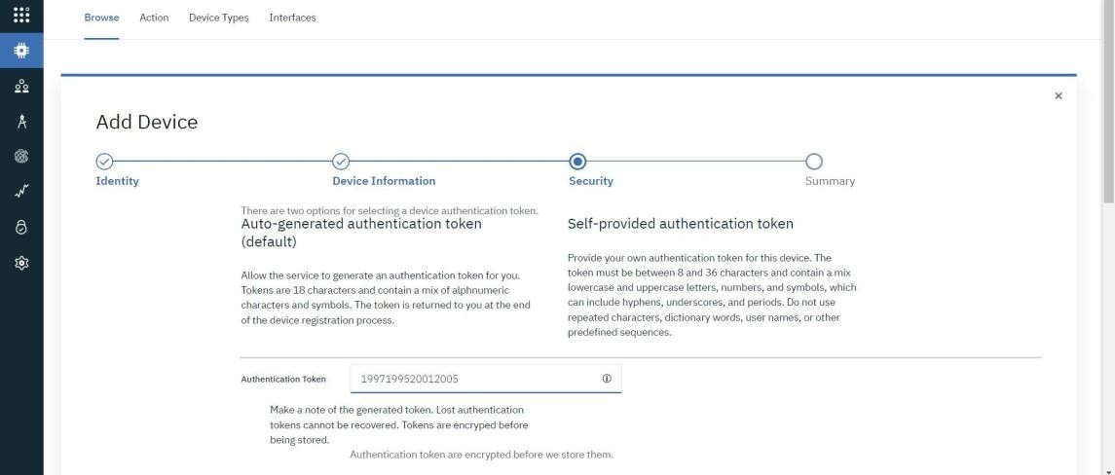

1. After selecting Next, the device's summary is displayed. Finally, select Finish.

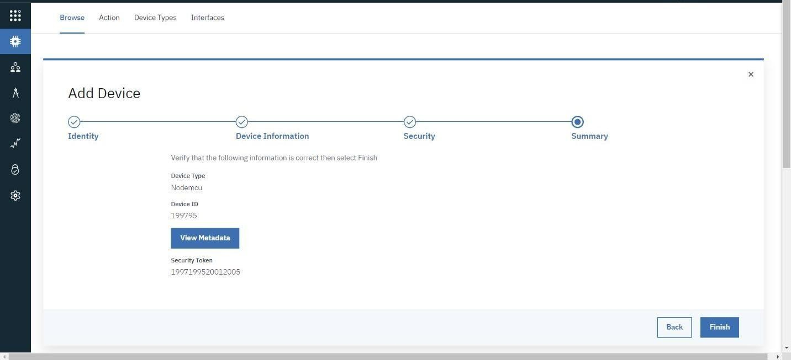

1. A detailed display of the device credentials will appear.
2. Protect the device information because authentication tokens are non- recoverable and must be created anew if lost..
3. We can now see the newly inserted device by clicking the device tab. The further information will be shown when you click on it. There are several tabs on it, including Identity, Device Information, State, and Login. According to the specifications of our project, we can similarly create n number of devices with a 50 per page limit.
4. The project cards will be displayed on the boards.

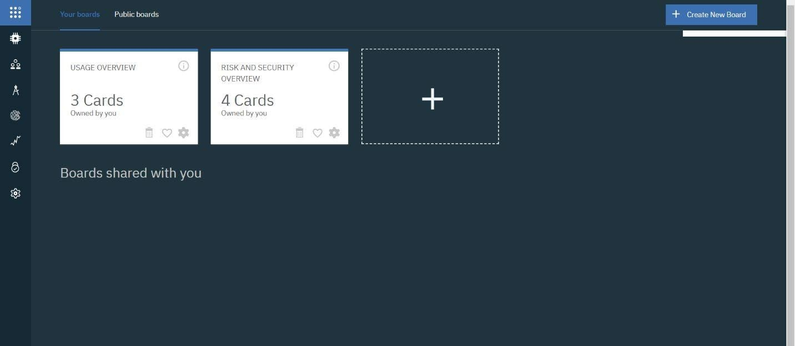

# CONCLUSION:

A device and an IBM Watson cloud are developed.